**Experiment No. 2.1**

**Student Name: Rishav Kumar UID: 22MCC20039**

**Branch: MCA - CCD Section/Group: MCD-1/ Grp A**

**Semester: III Date of Performance: 19th Sep 23**

**Subject Name: DevOps Process Automation Lab Subject Code: 22CAP-745**

1. **Aim/Overview of the practical:**

Create a Jenkins Freestyle Project which consists of Maven Build jobs.

***Note:*** Trigger the builds of all the Maven 9 Goals.

**Code for practical:**

* Open Jenkins on localhost and login with your credentials.
* Create a new job on ***New Item>Freestyle Project***.

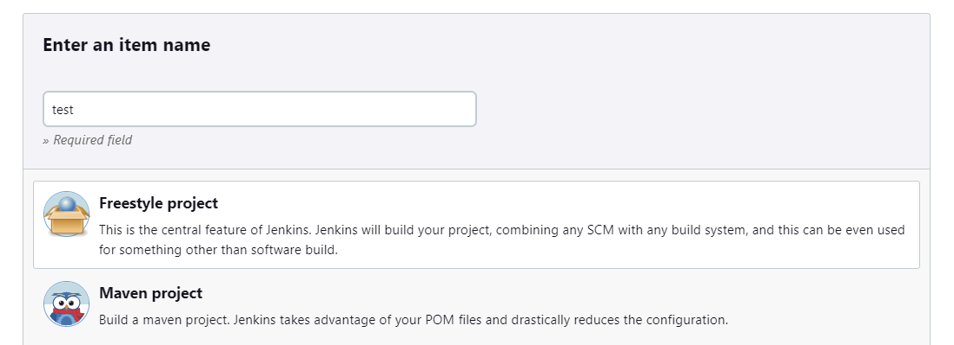

* Enter description of job and select git from Source Code Management
* Enter repository URL and select branch

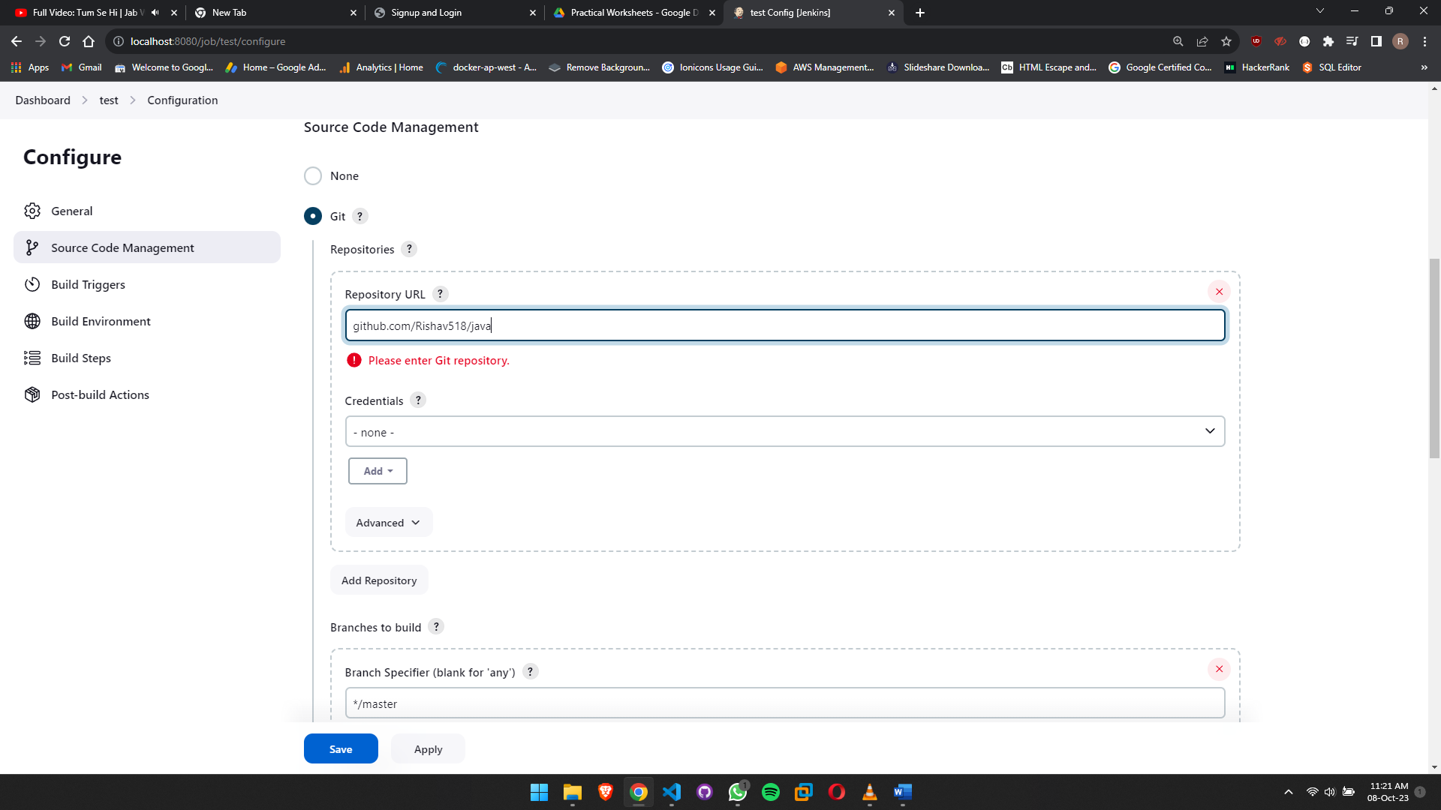

* Now, select ***Invoke top-level Maven targets*** in Build Steps.
* Enter maven command like **mvn test** or **mvn compile** which you want to execute.
* Click on Save.
* Click on build now button to build project.
* Project will be built in some minutes.
* Use same steps to achieve all 9 goals.

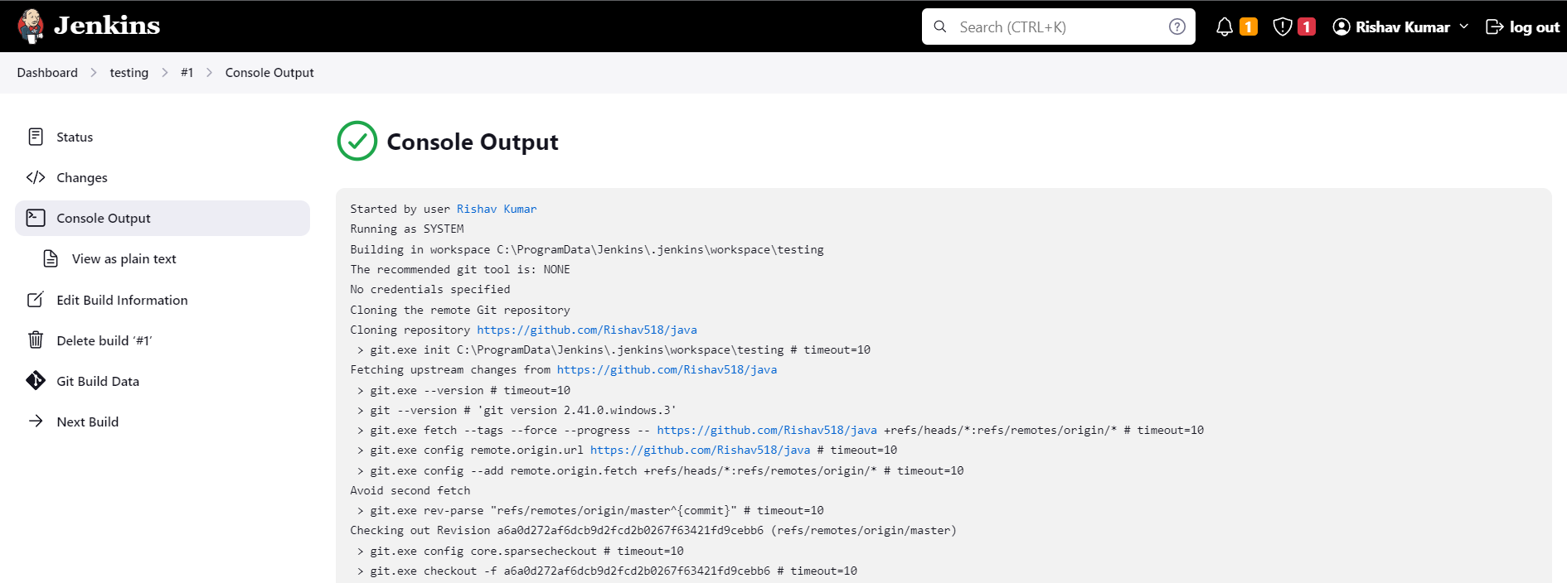

**************************************** **THE END** ***********************************************